June 2026

Eastern National Forests

Interpretive Association

ENFIA NEWSLETTER

Green Mountain & Finger Lakes National Forest
By: Martina Barne
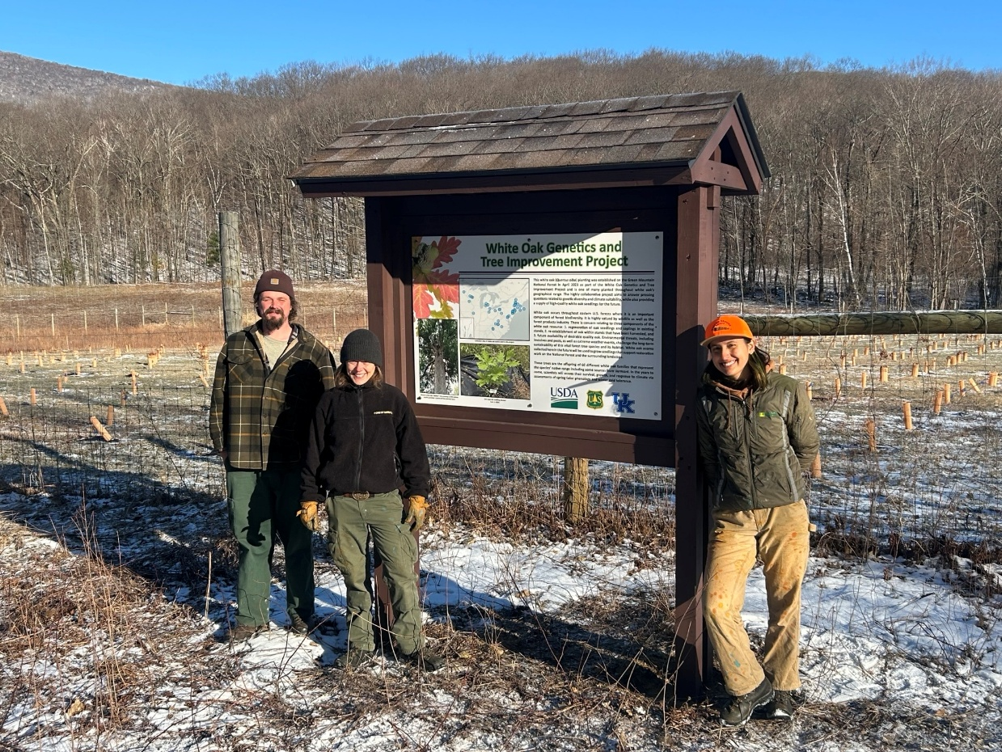
The White Oak Genetics and Tree Improvement Project is located on Bowen Hill Road in East Dorset, Vermont. As part of the project, a white oak (Quercus alba) planting was established on the Green Mountain National Forest in April 2023. These seedlings are the offspring of 40+ different white oak families that represent the species’ native range including some sources from Vermont. The project area is surrounded by an eight-foot-high deer fence to protect the seedlings. Several members of the public have asked what is happening in this location. Some have shared their speculations about the purpose of the planting and associated enclosure. To better inform the public about the importance of the project and the purpose of the planting area, a wooden kiosk, consisting of a roof and supported by wooden post, was built to display a laminated sign to inform the public about the project. The informational sign describes the environmental threats, including invasives pests and a warming climate, that challenge the long-term sustainability of this vital forest tree species and its habitat. The sign also displays the general locations of the many other sites that are a part of the project. White oak seed collected here will be used to grow seedlings that support restoration work on the National Forest and the surrounding landscape. In future years, scientists will assess their survival, growth, and response to climate via assessments of spring foliar phenology and winter cold tolerance. Currently, this project is funded by the U.S. Department of Agriculture’s USDA Forest Service, and the University of Kentucky.
Monongahela National Forest
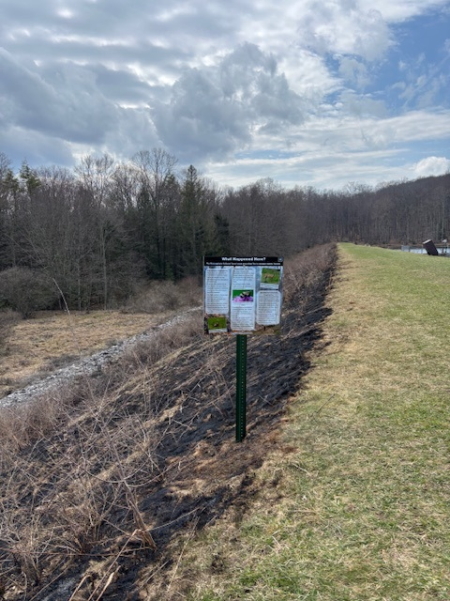

Wildlife Habitat/Recreation Interface Signage

The goals of the project are to provide interpretive signage on trails and recreation sites to explain both natural ecosystem dynamics as well as restoration work that the Forest Service and partners are conducting adjacent to recreation facilities and trails.
Signs have been used at prescribed burn project sites to provide information to visitors of the benefits of using fire as a tool for habitat restoration. The photos below are from Summit Lake dam and Lockridge Mountain burn units. The opportunity has not yet presented itself to use the beaver signs.

Send suggestions and topics for future newsletters to: enfiamich@gmail.com
Eastern National Forests

Interpretive Association

311 N. State Street Oscoda MI 48750
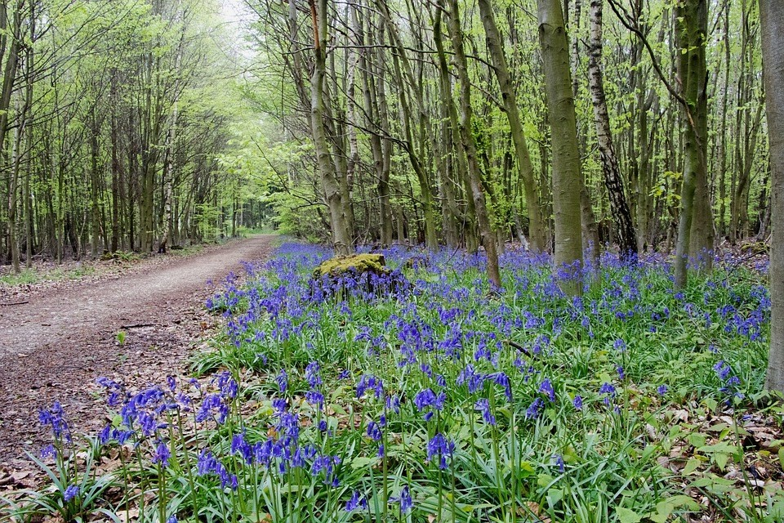
Email: enfiamich@gmail.com
 | 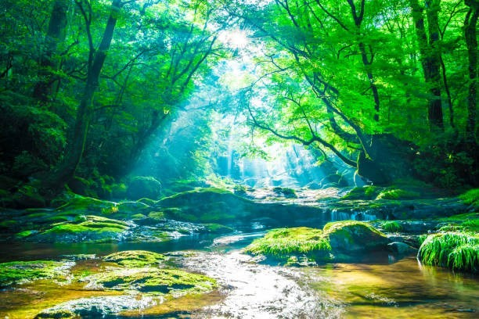  Forests supported by ENFIA:  Allegheny NF  Chippewa NF  Green Mountain &  Finger Lakes NF  Hiawatha NF  Hoosier NF  Huron-Manistee NF  Monongahela NF  Superior NF Wayne NF
Help ENFIA grow by contacting a forest that has dropped out or new ones that might consider joining.

